23.21: a) 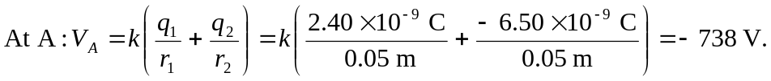
b) 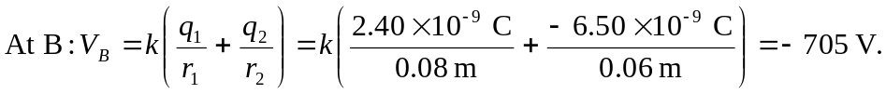
c)
The negative sign indicates that the work is done on the charge. So the work done by the field is 